**Asset - Starter**

* **How to use**
* **Tips**

**How to use**

* Open the creation window



* Drag the creation window to any window tab  
  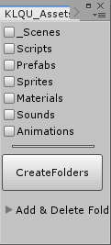  
  like this   
  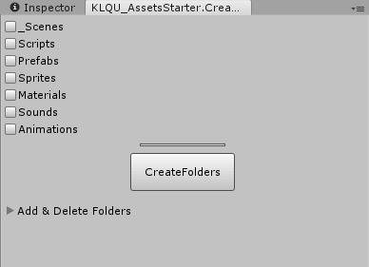

* You can chose the folder that you want to create and you can edit their names   
  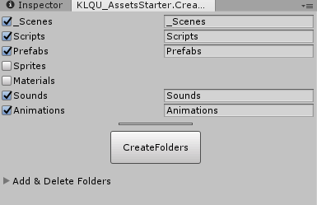
* You can add or delete folder to folders list  
  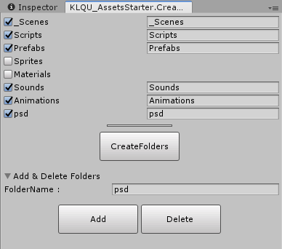
* After you decide what you want to create you can press the "CreateFolders" button and the folders will be created under "_AppAssets" Folder  
  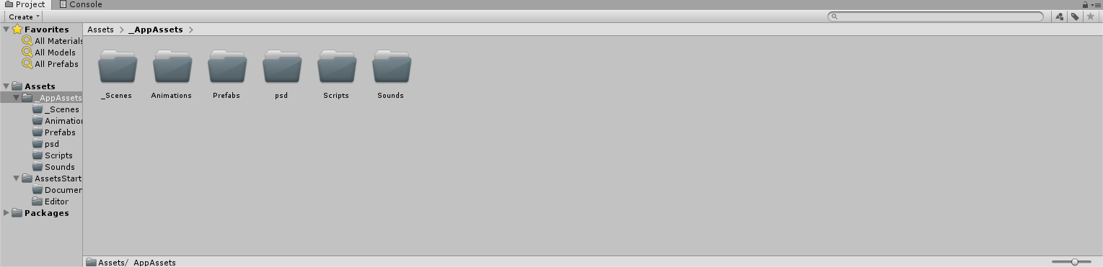

**Tips**

* if your project have Scene Folder and it have SampleScene it will moved automatically to "\Assets\_AppAssets\_Scenes\" folder